Smart Department Automation:
Projector Switch Automation and
Lab Occupancy Display System


Session 2024 - 2028

Submitted by:

Mahnoor Shabbir 2024-CS-69
Minahil Mehmood 2024-CS-86
Aatika Yousuf 2024-CS-95
Mahnoor 2024-CS-96

Supervised by:
Syed Tehseen Ul Hasan Shah

Subject:
CSC-205L Computer Organization & Assembly Language

Department of Computer Science
University of Engineering and Technology Lahore
Lahore Pakistan

Abstract:
This project presents a small-scale department automation system developed for Computer Organization and Assembly Language. The system contains two practical modules: Projector Servo Automation and Smart Lab Occupancy Indicator. The first module uses an Arduino Uno, push button, and servo motor to physically press the power button of a ceiling-mounted projector as in many classrooms, the projector button is difficult to reach, so students or teachers use a long stick to turn it on or off. The second module uses an ESP32 and a 16x2 I2C LCD to show whether Lab is free or occupied according to the stored department timetable. Students often enter labs to check availability, which can disturb an ongoing class and make the instructor lose tempo. Together, both modules solve real problems currently being faced in the department and demonstrate hardware interfacing, digital input/output, timing, stored-program execution, and microcontroller-based decision making in a deployable departmental context.

Table of Contents
1. Introduction: 4
2. Methodology: 4
3. System Overview: 4
4. Module 1: Projector Servo Automation 5
4.1 Introduction: 5
4.2 Components: 5
4.3 Implementation: 5
4.4 Complete Code: 6
4.5 Data Flow Diagram (DFD): 7
4.6 Flowchart: 7
4.7 Circuit Diagram: 8
5. Module 2: Smart Lab Occupancy Indicator 8
5.1 Introduction: 8
5.2 Components: 8
5.3 Implementation: 8
5.4 Lab 1 Timetable: 9
5.5 Complete Code: 10
5.6 Data Flow Diagram (DFD): 13
5.7 Flowchart: 13
5.8 Circuit Diagram: 14
6. Future Works: 14
7. Project Links: 14
8. References: 15

Table Of Figures:
Figure 1: System Overview 5
Table 1: Projector Servo Automation Components 5
Table 2: Projector Servo Automation Pin Connections 6
Figure 2: Projector Servo Automation Code 7
Figure 3: DFD of Projector Servo Automation 8
Figure 4: Flowchart of Projector Servo Automation 8
Figure 5: Circuit Diagram of Projector Servo Automation 9
Table 3: Smart Lab Occupancy Indicator Components 9
Table 4: Smart Lab Occupancy Indicator Pin Connections 10
Table 5: Lab1 Extracted Timetable Used in Code 10
Figure 6: DFD of Smart Lab Occupancy Indicator 14
Figure 7: Flowchart of Smart Lab Occupancy Indicator 14
Figure 8: Circuit Diagram of Smart Lab Occupancy Indicator 15
Table 6: Project Links 15

1. Introduction:
Departments often face small operational problems that can be reduced through simple automation. In classrooms, ceiling-mounted projectors are difficult to turn on or off when the remote is unavailable. In computer labs, students may not know whether a lab is free or occupied, causing repeated entry and disturbance during ongoing classes.
This project addresses both issues using microcontroller-based hardware. The first module automates the physical pressing of a projector button. The second module displays Lab1 availability outside the lab according to the timetable. The system is intentionally low-cost and modular, so each part can be deployed independently.

2. Methodology:
The project was divided into two modules. Each module was first designed at the circuit and logic level, then simulated, coded, and tested on hardware. The projector module uses a push button as input and a servo motor as output. When the button is pressed, the Arduino checks the input pin. If the button is pressed, the servo moves from its rest angle to the pressing angle. After a small delay, it moves back to its original position. This completes one button press.
The lab occupancy module uses time data and a stored timetable to decide what should appear on the LCD display. The ESP32 is used as the main controller. It gets the current time through Wi-Fi using NTP. The CS Department’s Lab1 timetable is stored in the code using a structure. Each timetable entry has the day, start time, end time, subject, teacher, and section. ESP32 checks the current day and time. If the current time falls inside any scheduled slot, the LCD shows that Lab1 is occupied. If no slot matches, the LCD shows that Lab1 is free and displays the next class time.
Both modules follow a simple embedded-system pattern: input is received, the microcontroller processes the stored instructions, and the output device performs the required action. This also supports the COAL perspective because the project demonstrates input/output interfacing, timing, control signals, and memory-stored program behavior.

3. System Overview:
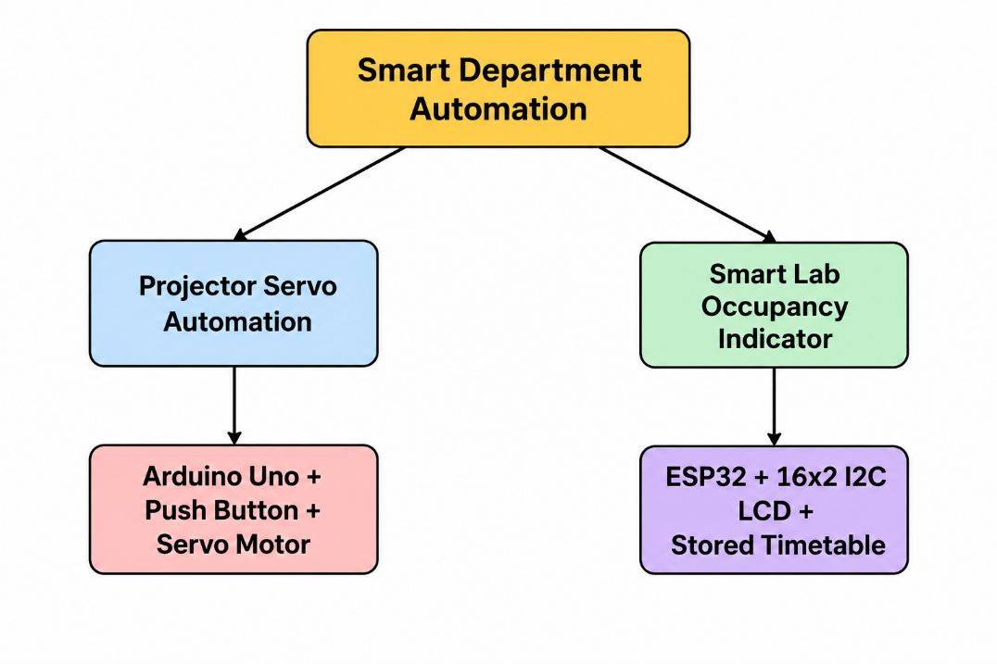
Figure 1: System Overview

4. Module 1: Projector Servo Automation

4.1 Introduction:
Projectors in classrooms are usually mounted on the ceiling, which makes their power buttons hard to access. This creates inconvenience during lectures, especially when the remote is missing or not working. The aim of this module is to provide a simple and low-cost solution by using an Arduino-controlled servo motor. When the push button is pressed, the Arduino sends a signal to the servo motor. The servo arm rotates, presses the projector button, and then returns to its original position

4.2 Components:
Table 1: Projector Servo Automation Components
Component | Purpose
Arduino Uno | Main controller of the system
Breadboard | Used for circuit assembly
Servo Motor | Physically presses the projector button
Push Button | Used to trigger the servo
Jumper Wires | Used to connect components
Connector Cable | Used to power and program the Arduino
Led | Used to indicate the successful working of servo

4.3 Implementation:
The push button is connected to digital pin 13 of the Arduino. The input pin uses the internal pull-up resistor, so no external resistor is required. The servo signal wire is connected to digital pin 6. The servo starts at 90 degrees and rotates to the pressing angle when the button is pressed. After a short delay, the servo returns to its rest position.
Table 2: Projector Servo Automation Pin Connections
Part | Arduino Pin
Push button one side | D13
Push button other side | GND
Servo signal | D6
Servo VCC | 5V
Servo GND | GND
Led button anode | D2
Led button cathode | GND

4.4 Code:

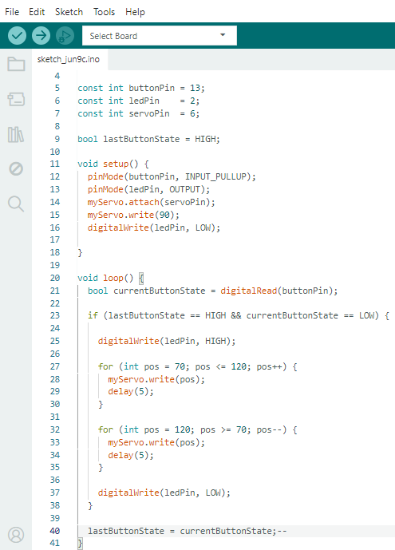
Figure 2: Projector Servo Automation Code

4.5 Data Flow Diagram (DFD):
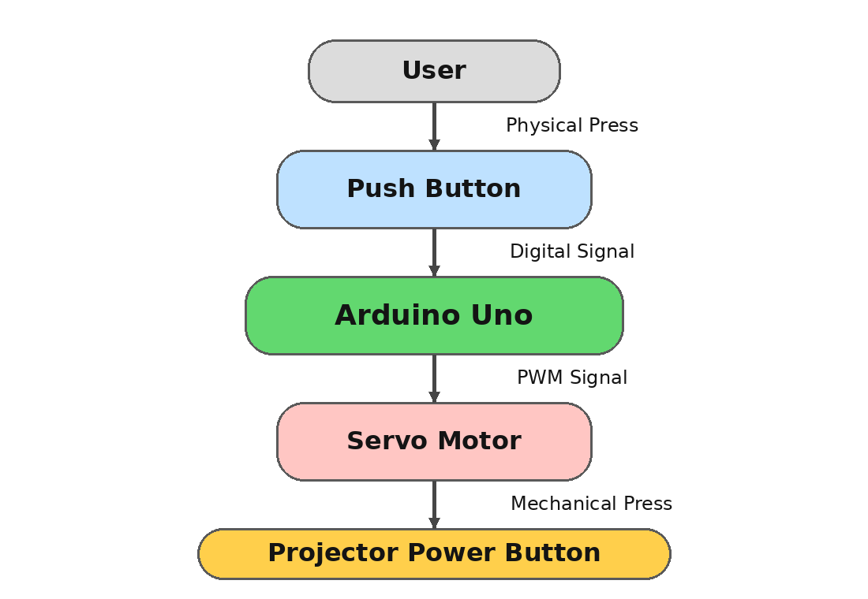
Figure 3: DFD of Projector Servo Automation

4.6 Flowchart:
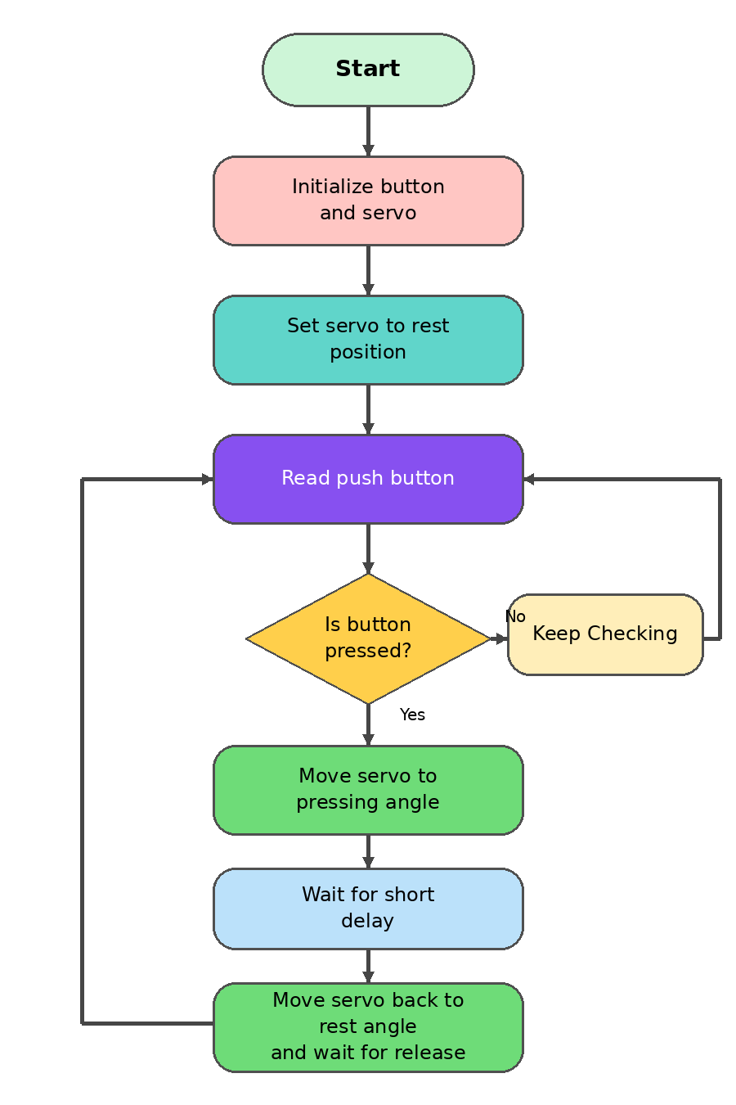
Figure 4: Flowchart of Projector Servo Automation

4.7 Circuit Diagram:

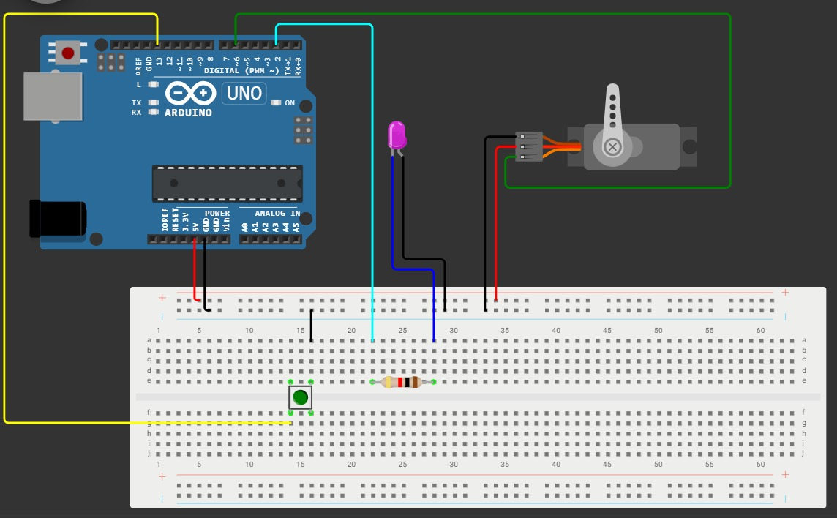
Figure 5: Circuit Diagram of Projector Servo Automation

5. Module 2: Smart Lab Occupancy Indicator

5.1 Introduction:
Students often do not know whether a lab is currently free or in use. Entering the lab to check availability can disturb an ongoing class. The Smart Lab Occupancy Indicator solves this by showing the lab status outside the lab using a small display.

5.2 Components:
Table 3: Smart Lab Occupancy Indicator Components
Component | Purpose
ESP32 | Main controller
16x2 I2C LCD | Displays lab status
Jumper Wires | Used for connections
USB Cable | Used for programming and power

5.3 Implementation:
The LCD is connected to the ESP32 using I2C communication. GPIO 21 is used as SDA and GPIO 22 is used as SCL. The ESP32 gets the current time through Wi-Fi using NTP. The timetable is stored directly in the program using a structure, where every class slot has the day, start time, end time, subject, teacher, and section.

Table 4: Smart Lab Occupancy Indicator Pin Connections
LCD Pin | ESP32 Pin
VCC | VIN / 5V
GND | GND
SDA | GPIO 21
SCL | GPIO 22

The time is converted into minutes so that comparison becomes easy. For example, 08:00 is stored as 480 minutes and 13:00 is stored as 780 minutes. If the current time falls between a class start and end time, the lab is shown as occupied. Otherwise, it is shown as free and the next class is displayed.

5.4 Lab 1 Timetable:
Table 5: Lab1 Extracted Timetable Used in Code
Day | Time | Status | Class / Section | Lecture / Lab | Instructor
Monday | 08:00-11:00 | Occupied | 4th Semester / D | ISL | Mr. Kamran Mustafa
Monday | 11:00-12:00 | Occupied | 4th Semester / D | DAA | Dr. Maimoona Salam
Monday | 13:00-16:00 | Occupied | 4th Semester / D | ADMSL | Mr. Waleed
Monday | 16:00-19:00 | Occupied | 2nd Semester / D | DSL | Dr. Maimoona Salam
Tuesday | 08:00-11:00 | Occupied | 2nd Semester / B | DSL | Ms. Hafsa
Tuesday | 13:00-16:00 | Occupied | 2nd Semester / D | OOPL | Mr. Muzaffar Ali
Tuesday | 16:00-19:00 | Occupied | 1st Semester / A | PFL | Mr. Laeeq
Wednesday | 08:00-09:00 | Occupied | 4th Semester / B | ToA | Dr. Tauqir Ahmed
Wednesday | 09:00-12:00 | Occupied | 4th Semester / B | COALL | Syed Tehseen ul Hassan Shah
Wednesday | 13:00-16:00 | Occupied | 2nd Semester / E | DSL | Mr. Nazeef-ul-haq
Thursday | 08:00-11:00 | Occupied | 4th Semester / B | ADMSL | Mr. Waleed
Thursday | 11:00-12:00 | Occupied | 4th Semester / B | DAA | Dr. Amna Zafar
Thursday | 13:00-16:00 | Occupied | 4th Semester / B | ISL | Mr. Kamran Mustafa
Thursday | 16:00-19:00 | Occupied | 2nd Semester / D | OOPL | Ms. Nimra Akram
Friday | 08:00-11:00 | Occupied | 2nd Semester / E | OOPL | Ms. Nimra Akram

5.5 Code:
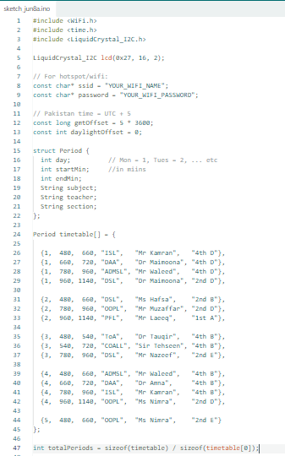
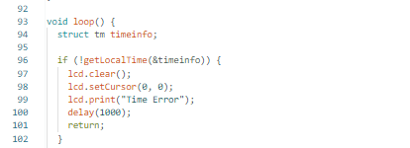
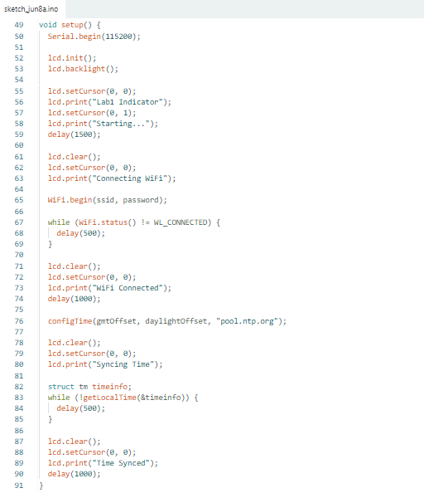

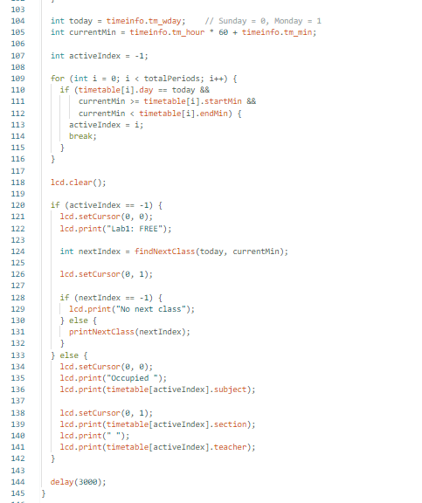

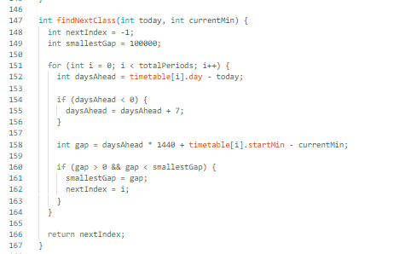

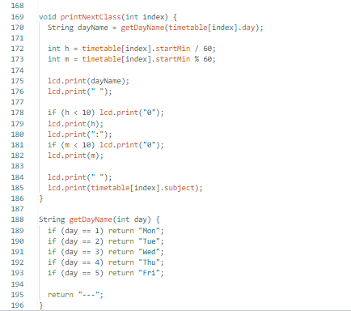

5.6 Data Flow Diagram (DFD):
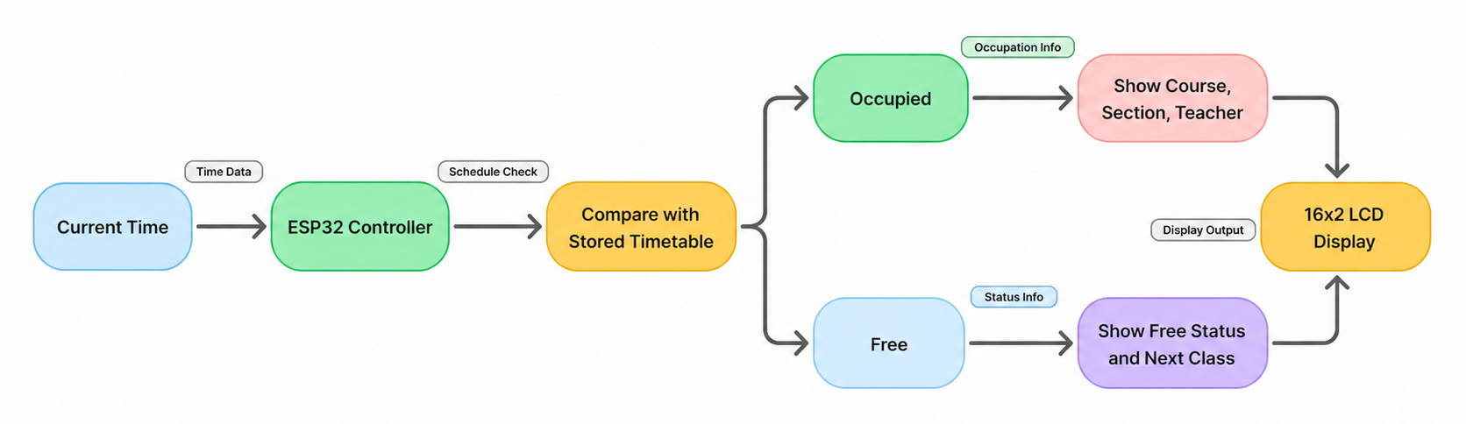
Figure 6: DFD of Smart Lab Occupancy Indicator

5.7 Flowchart:
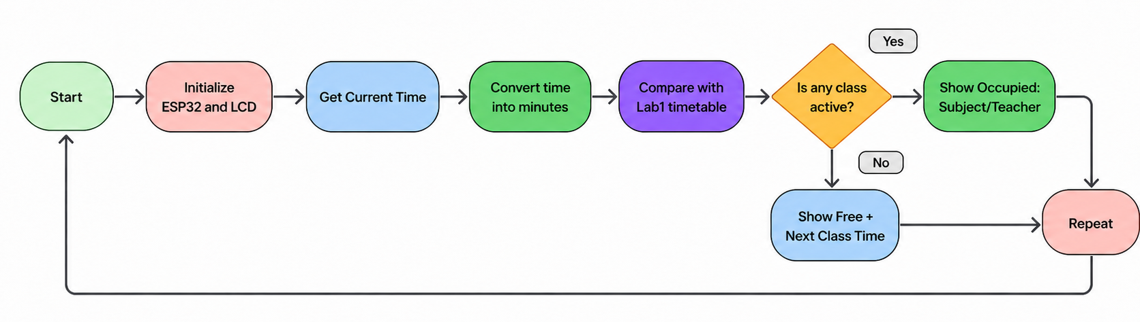
Figure 7: Flowchart of Smart Lab Occupancy Indicator

5.8 Circuit Diagram:

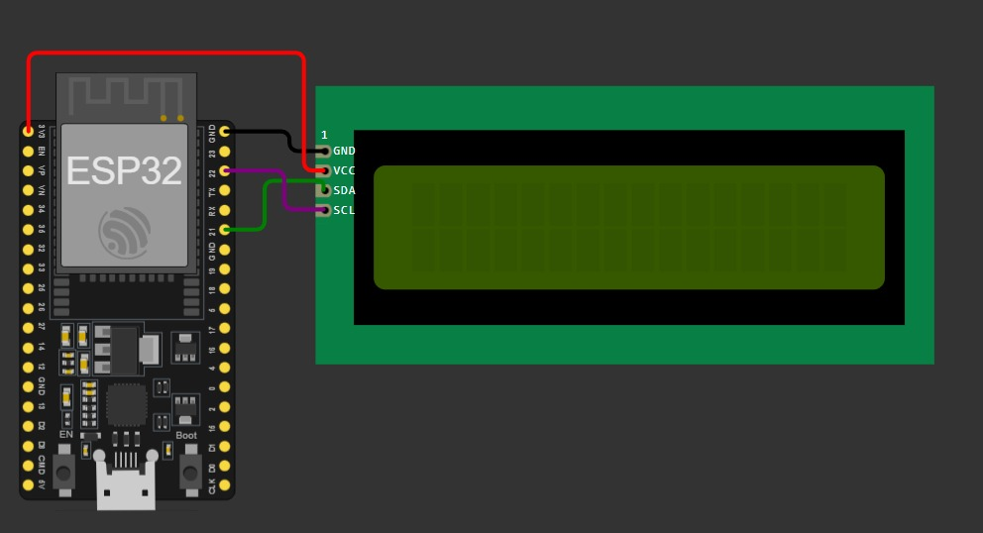
Figure 8: Circuit Diagram of Smart Lab Occupancy Indicator

6. Future Works:
The projector this module can be improved by adding a proper mounting frame for the servo motor. An external power supply can also be used for better servo stability. The system can also be upgraded by using an IR transmitter or wireless control so that the projector can be controlled without physically pressing the button. A feedback mechanism can also be added to confirm whether the projector button was pressed successfully or not.
The lab occupancy module can be extended by adding Firebase or a web dashboard so that the timetable can be updated without re-uploading the ESP32 code. Multiple labs can be supported by using one display per lab or by using a central dashboard. An RTC module can also be added to keep time when Wi-Fi is not available.

7. Project Links:
Table 6 Project Links
Link Type | URL / Status
GitHub Repository | https://github.com/aatikayousuf/Department-Automation-Coal-Project.git
Wokwi Simulation - Projector Servo Automation | https://wokwi.com/projects/462899679951199233
Wokwi Simulation - Lab Occupancy Indicator | https://wokwi.com/projects/new/esp32
LinkedIn Post

8. References:

- Arduino Uno Rev3 Documentation: https://docs.arduino.cc/hardware/uno-rev3/
- Arduino Servo Motor Basics: https://docs.arduino.cc/learn/electronics/servo-motors
- Arduino Digital Input Pull-Up Concept: https://docs.arduino.cc/tutorials/generic/digital-input-pullup/
- Arduino IDE Download: https://www.arduino.cc/en/software
- Wokwi Simulation Platform: https://wokwi.com/
- ESP32 Arduino Core Documentation: https://docs.espressif.com/projects/arduino-esp32/en/latest/
- ESP32 Wi-Fi API: https://docs.espressif.com/projects/arduino-esp32/en/latest/api/wifi.html
- Department Timetable: TimeTable 24-03-2026 onwards.pdf

